INDEX for Project Documentation

SR.NO | CONTENTS |  | Page. No
1. | Introduction |  | 2
 |  | Project Profile
2. | System Introduction |  | 3
 |  | System Definition, Objective, and scope
 |  | Hardware & Software Requirements
3. | Requirement Analysis & Modeling |  | 5
 |  | Expected working of the system
 |  | Data Flow Diagrams (DFD)
 |  | Process Specification
 |  | Data Dictionary
4. | Design |  | 17
 |  | ER Diagram & Database Design
 |  | System Architecture
 |  | System Flowchart
 |  | Form & Report Designs (Screenshots) Layouts
5. | Coding |  | 37
 |  | Coding Approach/style
 |  | Code Snippets
6. | Testing |  | 44
 |  | Testing Data Inputs ( Data Validations)
 |  | Testing Operations (Actions on each screen)
7. | New Tools/ Technologies learned/used |  | 49
8. | System Limitations/Restrictions and Dependencies/Constraints |  | 50
9. | Future Enhancement & Opportunities |  | 51
10. | Bibliography & References |  | 52

Introduction

1. INTRODUCTION

1.1 System Profile

- Project title : Blood & Bank Donation Management System
- Front-end : HTML , CSS , JS
- Back-end : PHP , MySQL
- Submitted By : Devani Yagnik N
- Project guided : By Dr. Priti Patel
- Organization : Shree Ramkrishna Institute of
Computer Education & Applied
Science

2. SYSTEM INTRODUCTION
System Introduction

2.1 System Definition, Objective and scope

2.1.1 System Information: -

- is designed in such a manner that it can suit the needs of all the blood bank requirements in The project blood bank management system is known to be a pilot project that is designed for the blood bank to gather blood from various sources and distribute it to needy people who have high requirements for it.

- The Software is designed to handle the daily transaction of the blood bank and Search the details when required.

- It also helps to register the details of donors, blood collection details, as well as blood, issued reports

- The software Application the course of the future.

- It will help us to find the Blood group with its most efficient time to take care of the blood and it is easier to hand over the blood to the hospital to help people to get blood on time.

- This all things have been stored and seen in this blood bank management system. To help more people try their best to do so.

System Introduction

2.1.2 Project Objective: -

- The main objective of the Blood Bank Management System is to manage the details of Blood, Donor, and Blood Group.
- It manages all the information about Blood.
- project is built at the administrative end and thus only the administrator is guaranteed the access
- Admin and user can operate the system 24/7.
- To check the availability of blood bags anytime
- To manage the information of its blood donor
- Support fast searching to find match blood bags for the right person.

2.1.3 System Scope: -

- Login function accessed by only admin .

- Admin can only delete user.

2.2 Hardware & Software Requirements

Hardware:-

- Processor : Intel core i3 or above

- Ram : 2 GB or above

- Hard-Disk : 100 GB or above

Software:-

- Backend : PHP & My Sql (PHP MY Admin).

- Frontend : HTML , CSS , JS

- Operating System : Windows 8 or above

3. REQUIREMENT ANALYSIS
Requirement analysis

3.1 Expected working of System

- Admin Module : Admin can login with username and password which is already store in
System database.

  - Login Facility
  - Donor Manage
  - Check Contact Query
  - Camp Manage
  - Pages Manages
  - Change Password
  - Logout

- User Module : User can donate blood and search blood donor as per blood group.

- View Pages
- View And Enroll Camp Details
- View Blood Donor Info
- Registration as Donor
- Search Available Blood
- Contact Admin

Requirement analysis

3.2 Data Flow Diagrams (DFD)

0 LEVEL DFD:-

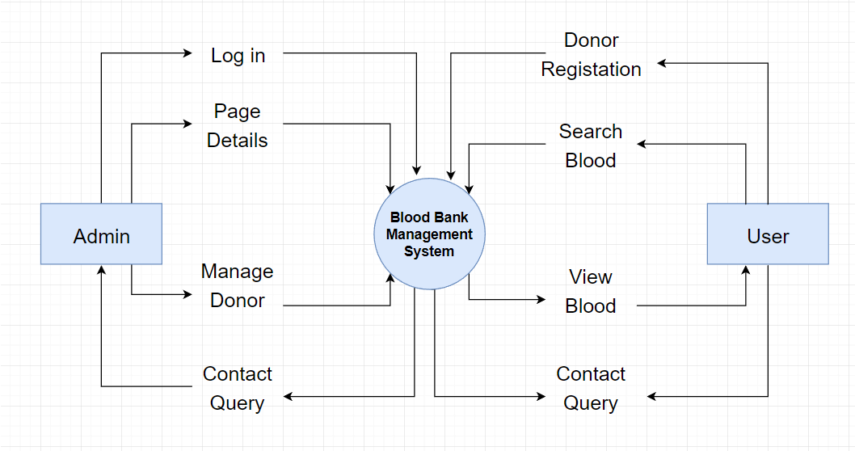

- 1st LEVEL DFD FOR ADMIN :-
Requirement analysis

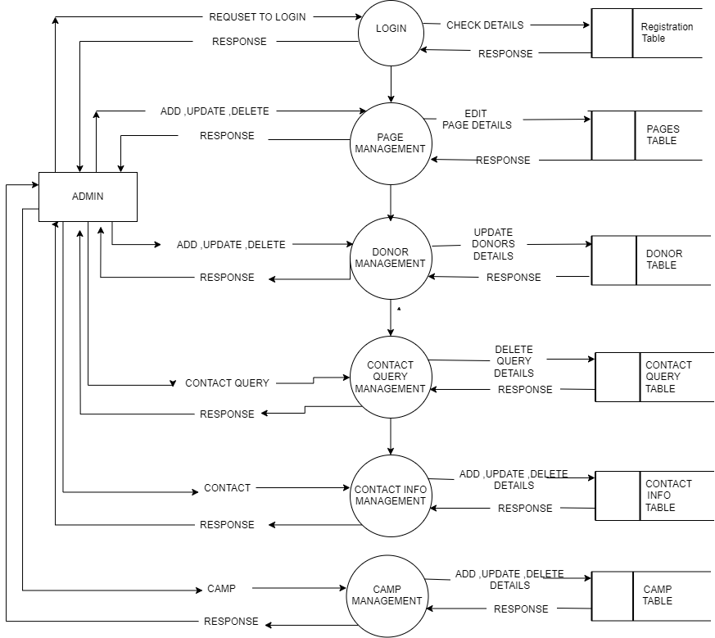

- 1st LEVEL DFD FOR ADMIN
Requirement analysis

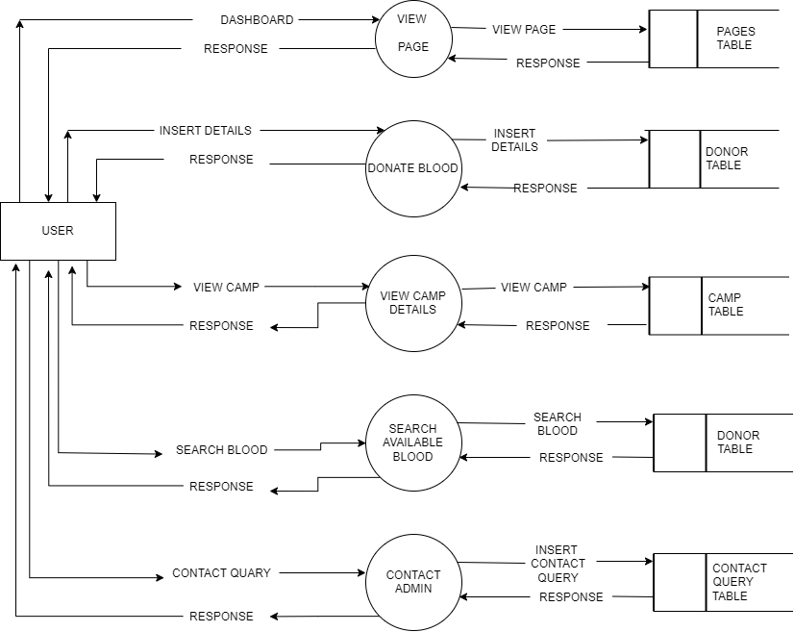

Requirement analysis

- 2nd LEVEL DFD FOR ADMIN :-

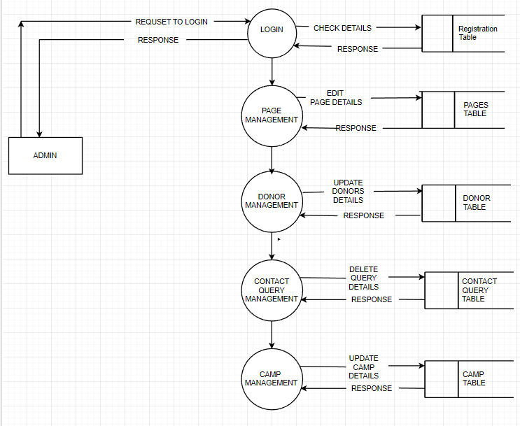

Requirement analysis

- 2ST LEVEL DFD FOR USER :-

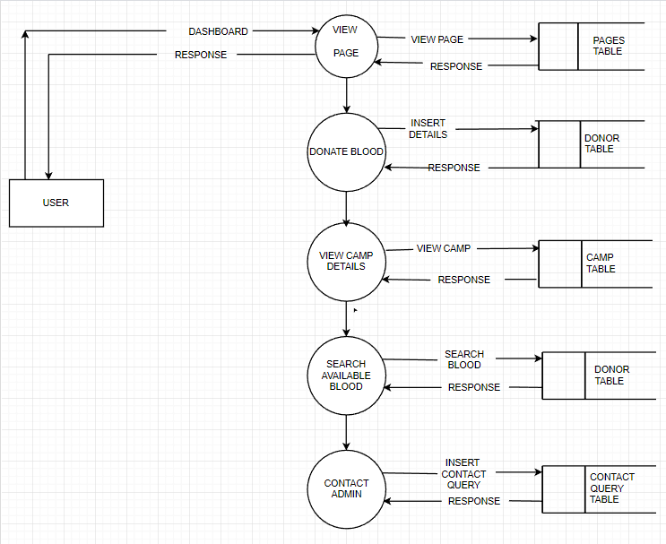

Requirement analysis

3.3 Process Specification

- PROCESS 1.0 :

Name: | Login
Description: | This process is save all the information of the trust manager and Admin like Username , Password etc.

- PROCESS 1.0 FOR DONOR:

Name: | Registration
Description: | This process is save all the information of the trust manager or camp manager and donor like Username , Password etc.

- PROCESS 2.0 FOR ADMIN:

Name | Manage User datails
Description: | Admin can update and delete donor details

Requirement analysis

- PROCESS 3.0 FOR ADMIN:

Name: | Manage Subject
Description: | Admin can add camp and also delete camp

- PROCESS 4.0 FOR Donor:

Name: | Fill query form
Description: | Donor can fill the query form.

- PROCESS 5.0 FOR User:

Name: | Search Available Blood
Description: | Users can search for available blood

- PROCESS 6.0 Blood Donation:

NAME: | Blood Donation
Description:- | New donor ADD DATA Internet

Requirement analysis

3.4 Data Dictionary

- Admin Table

Name: | Admin Details
Alias: | Admin login
Where used/How used: | Data used for admin login
Content Description: | Admin id  Admin Name  Username  password

- Blood Table

Name: | Blood details
Alias: | System
Where used/How used: | Data use for a particular Blood name with Id
Content Description: | Blood id  Blood Group

- Camp Table

Name: | Camp details
Alias: | Camp
Where used/How used: | Camp Details for Admin and User
Content Description: | Camp id  Date  Camp Name  Address  Contact  Conducted By  Organized By  Time

- Enroll Camp Table

Name: | Camp Enroll Donor Details
Alias: | Camp
Where used/How used: | Data use for details of Enroll Donor
Content Description: | Id  Camp Name  Donor name  Number  Email  Age  Gender  Blood Group  Address  Camp id

- Contact Information Table

Name: | Contact Information
Alias: | Contact
Where used/How used: | Data use for post Contact view on user side
Content Description: | Id  Address  Mail  Phone

- Contact Query Table

Name: | Contact Query
Alias: | Solve problem
Where used/How used: | Data use for details of donor query
Content Description: | id  name  mail  number  message  date

- Donor Table

Name: | Donor details
Alias: | Donor
Where used/How used: | Donor Details use for Blood Donation
Content Description: | Id  Name  Number  Mail  Age  Gender  Blood  Address

- Page Table

Name: | Page details
Alias: | page
Where used/How used: | Page Details for User
Content Description: | Id  Page Name  Page Type  Page Data

4. Design
Design

4.1 ER Diagram :

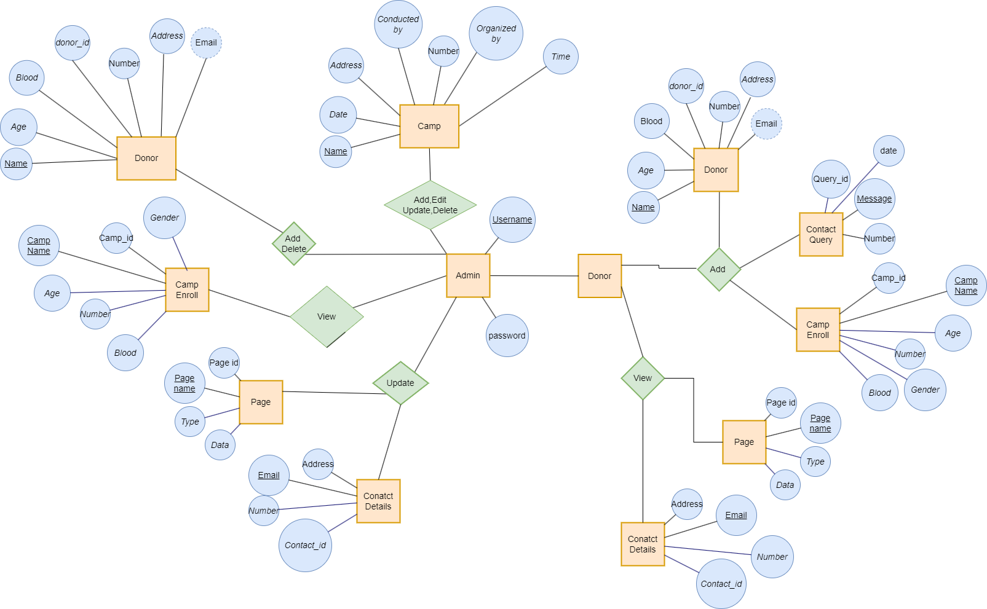
Design

4.1 Database Design

admin_info Table

Field Name | Data Type | Size | Constraint
Admin_id | int | 10 | Primary Key,  Auto increment
Admin_name | text | 50 | Not Null
Admin_username | varchar | 50 | Not Null
Admin_password | varchar | 50 | Not Null

blood Table

Field Name | Data Type | Size | Constraint
blood_id | int | 11 | Primary Key,  Auto increment
blood_group | text | 10 | Not Null

Design

camp Table

Field Name | Data Type | Size | Constraint
camp_id | int | 10 | Primary Key,  Auto increment
camp_name | text | 50 | Not Null
Date | Date | 50 | Not Null
Address | Varchar | 50 | Not Null
Contact | int | 10 | Not Null
Conductedby | text | 50 | Not Null
Organizedby | text | 50 | Not Null
time | varchar | 50 | Not Null

- camp_enroll

Field Name | Data Type | Size | Constraint
id | int | 11 | Primary Key,  Auto increment
Enroll_camp_name | varchar | 20 | Not Null
Enroll_name | varchar | 50 | Not Null
Enroll_number | int | 10 | Not Null
Enroll_email | varchar | 20 | Not Null
Enroll_age | int | 3 | Not Null
Enroll_gender | text | 6 | Not Null
Enroll_blood | varchar | 2 | Not Null
Enroll_address | varchar | 11 | Not Null
Camp_id | int | 11 | Foreign Key

Design

contact_info Table

Field Name | Data Type | Size | Constraint
contact_id | int | 10 | Primary Key,  Auto increment
contact_address | varchar | 50 | Not Null
contact_mail | Varchar | 50 | Not Null
contact_phone | int | 10 | Not Null

pages Table
Field Name | Data Type | Size | Constraint
page_id | int | 10 | Primary Key,  Auto increment
page_name | varchar | 255 | Not Null
Page_type | Varchar | 50 | Not Null
Page_data | longtext | - | Not Null

Design

donor_details Table

Field Name | Data Type | Size | Constraint
donor_id | int | 10 | Primary Key,  Auto increment
donor_name | text | 50 | Not Null
Donor_number | Int | 10 | Not Null
Donor_mail | Varchar | 50 | Not Null
Donor_age | int | 3 | Not Null
Donor_gender | varchar | 10 | Not Null
Donor_blood | varchar | 10 | Not Null
Donor_address | varchar | 100 | Not Null

Design

contact_query Table

Field Name | Data Type | Size | Constraint
query_id | Int | 10 | Primary Key,  Auto increment
query_name | text | 50 | Not Null
query_mail | Varchar | 100 | Not Null
query_number | int | 10 | Not Null
query_message | longtext | - | Not Null
date | timestamp | 50 | Not Null

4.3 System Flowchart :

4.1.1 Admin Side :

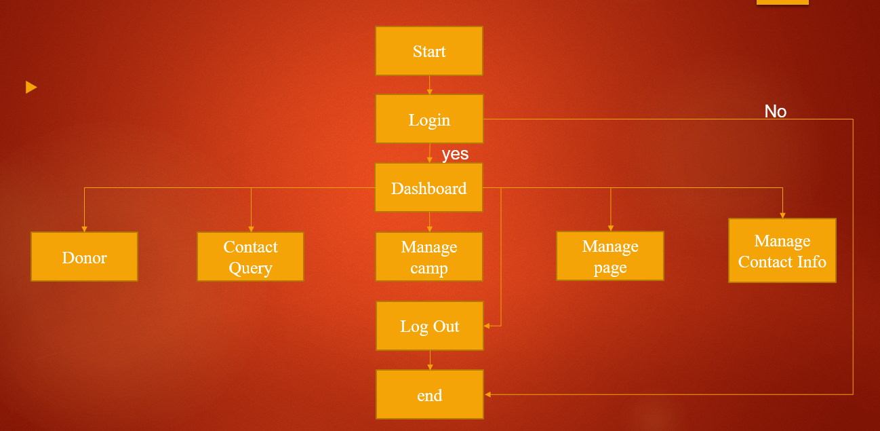

4.1.1 User Side :

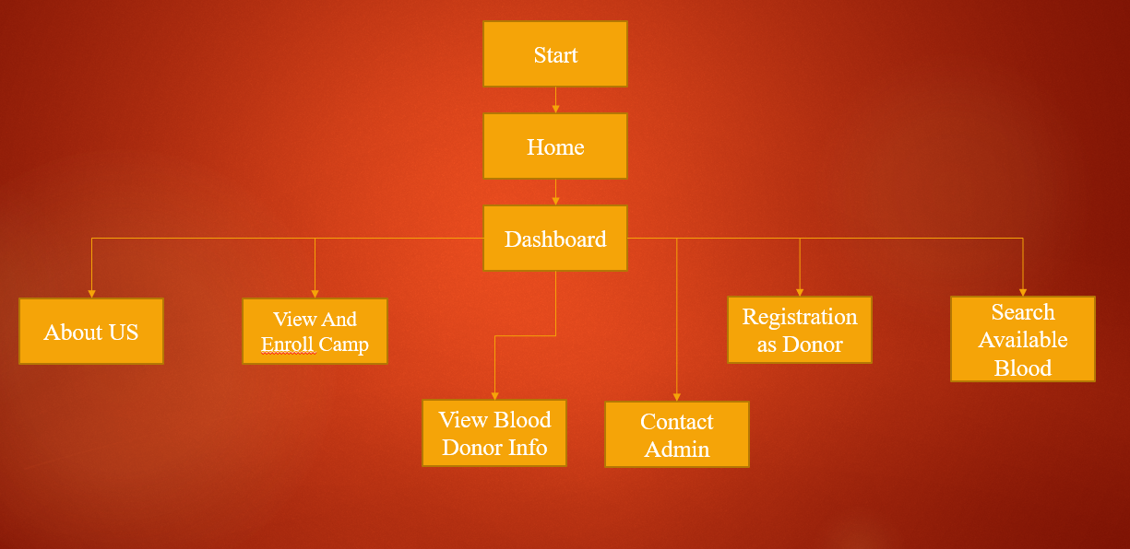

4.4 FORM AND REPORT DESIGN(SCREENSHOT)LAYOUT:
Design

Admin Side :

- Login Page

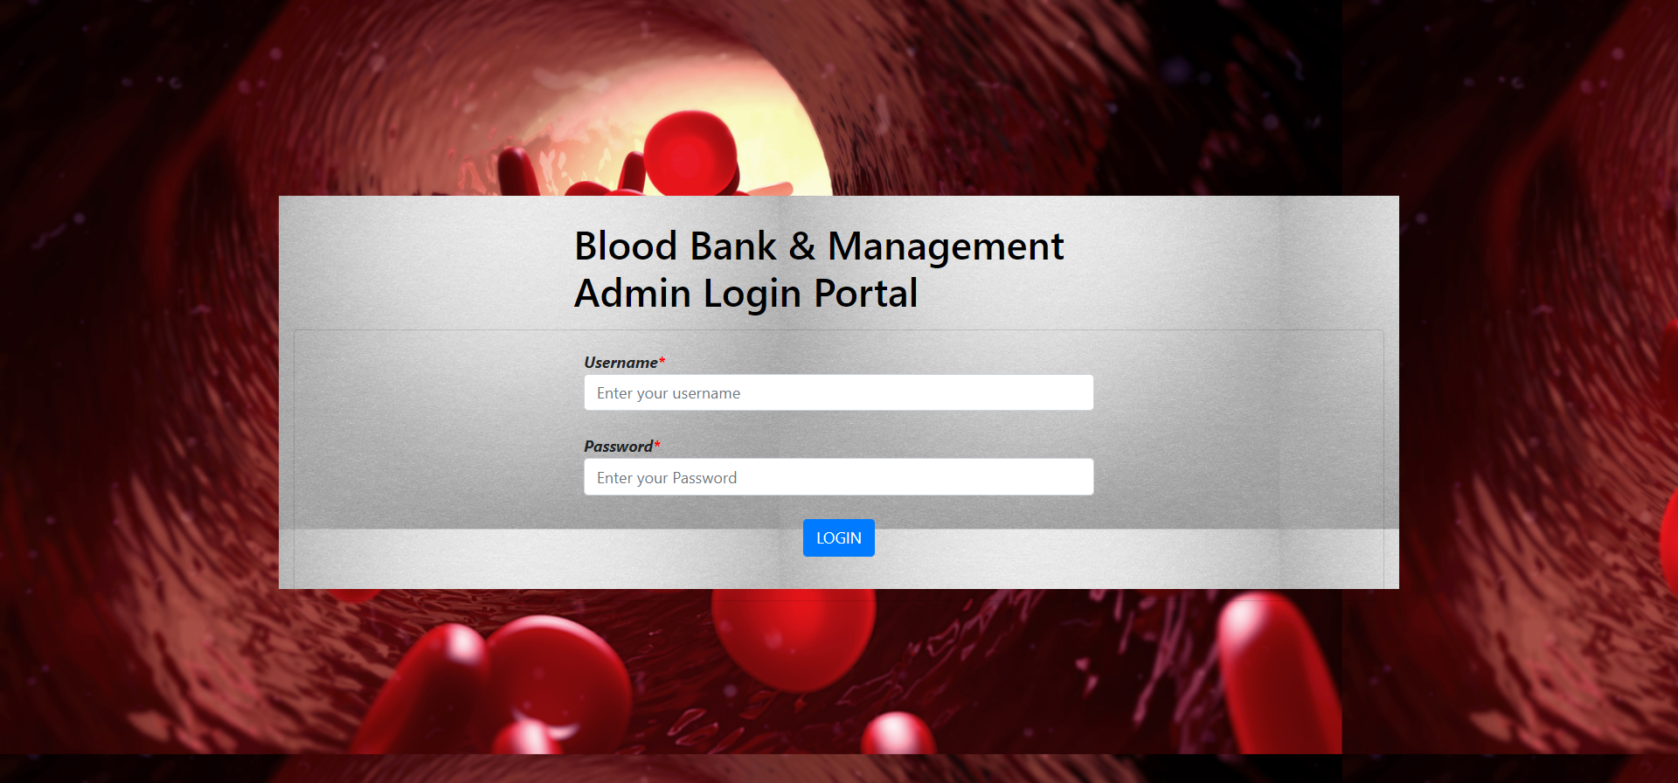
- Dashboard Page

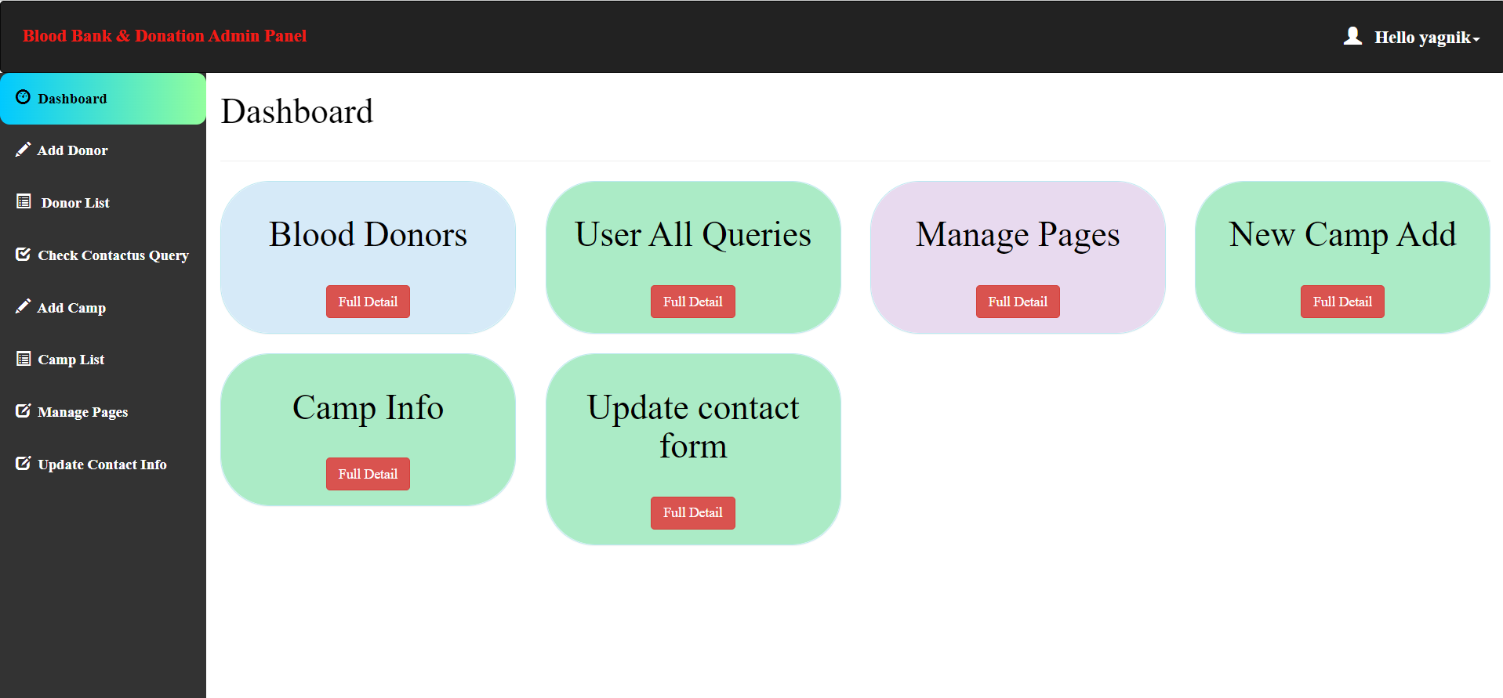
Design

- Add Donor Page

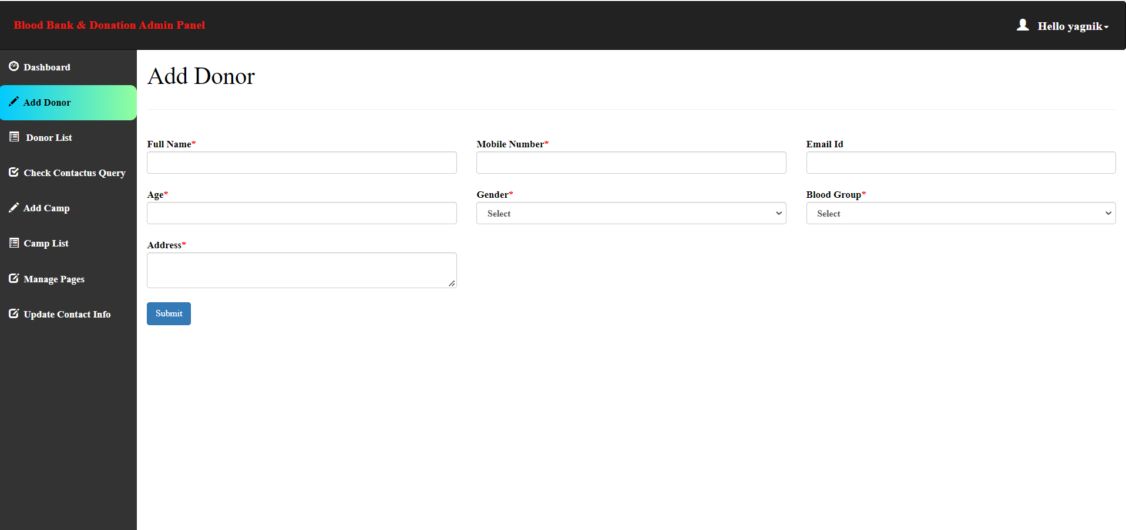

- Donor List Page

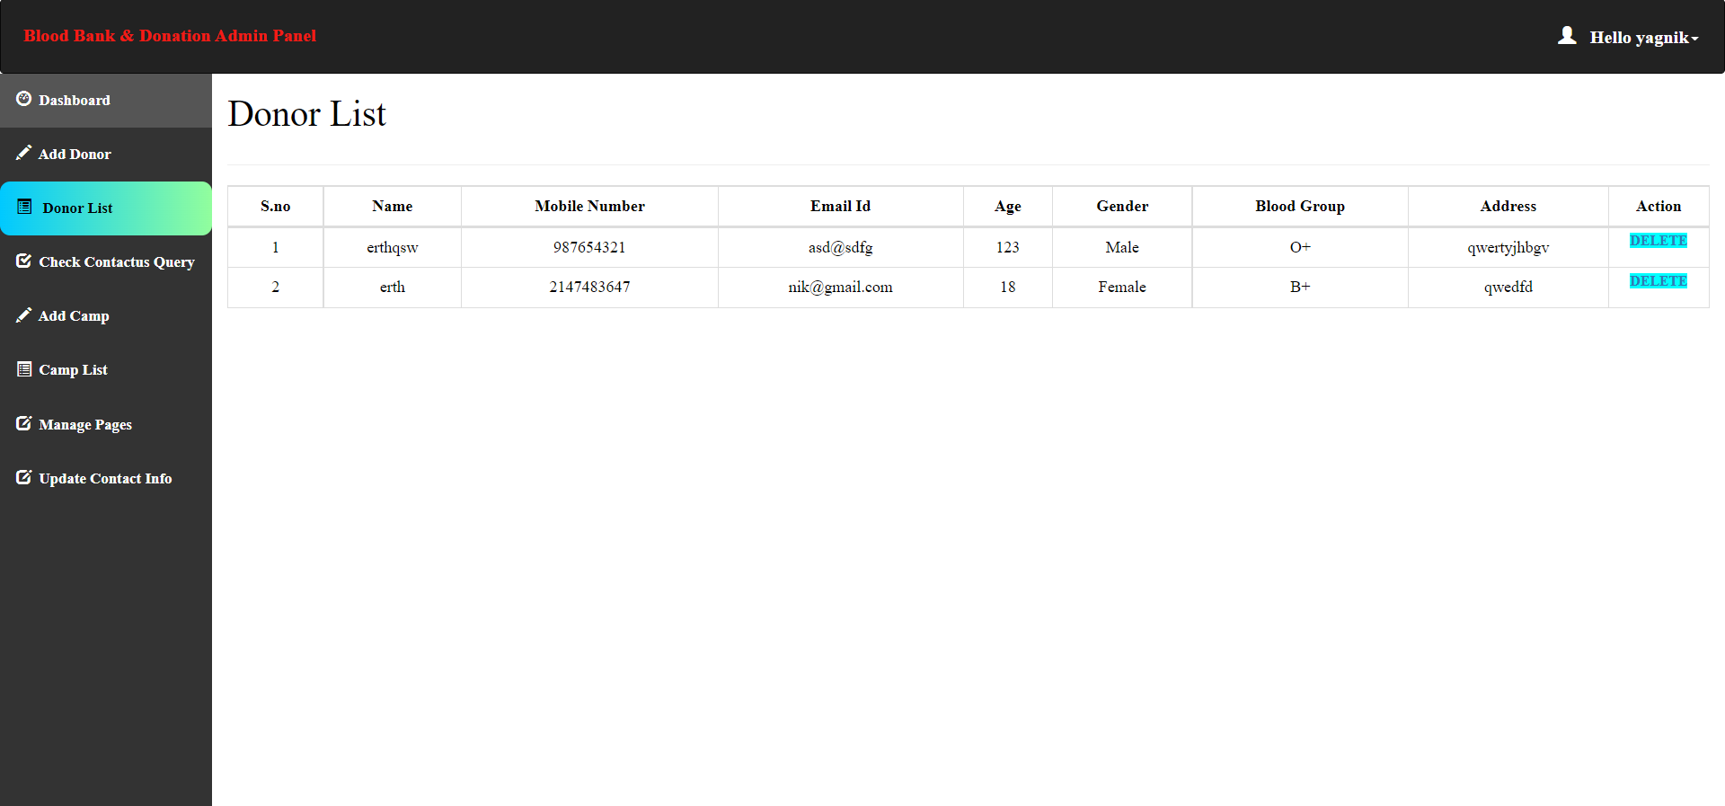
Design

- User Query Page

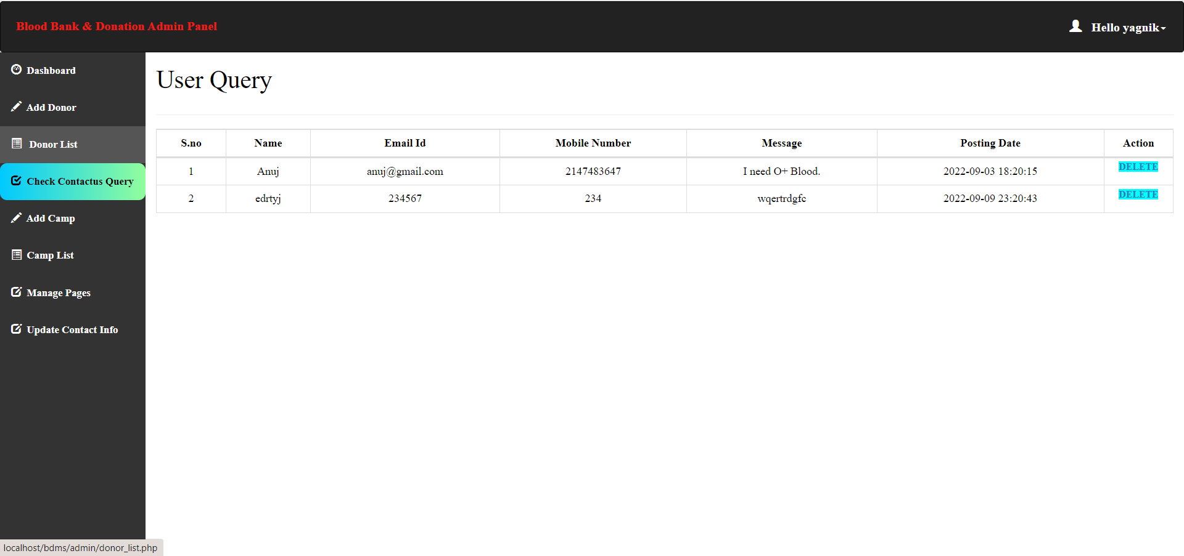

- Add Camp Page
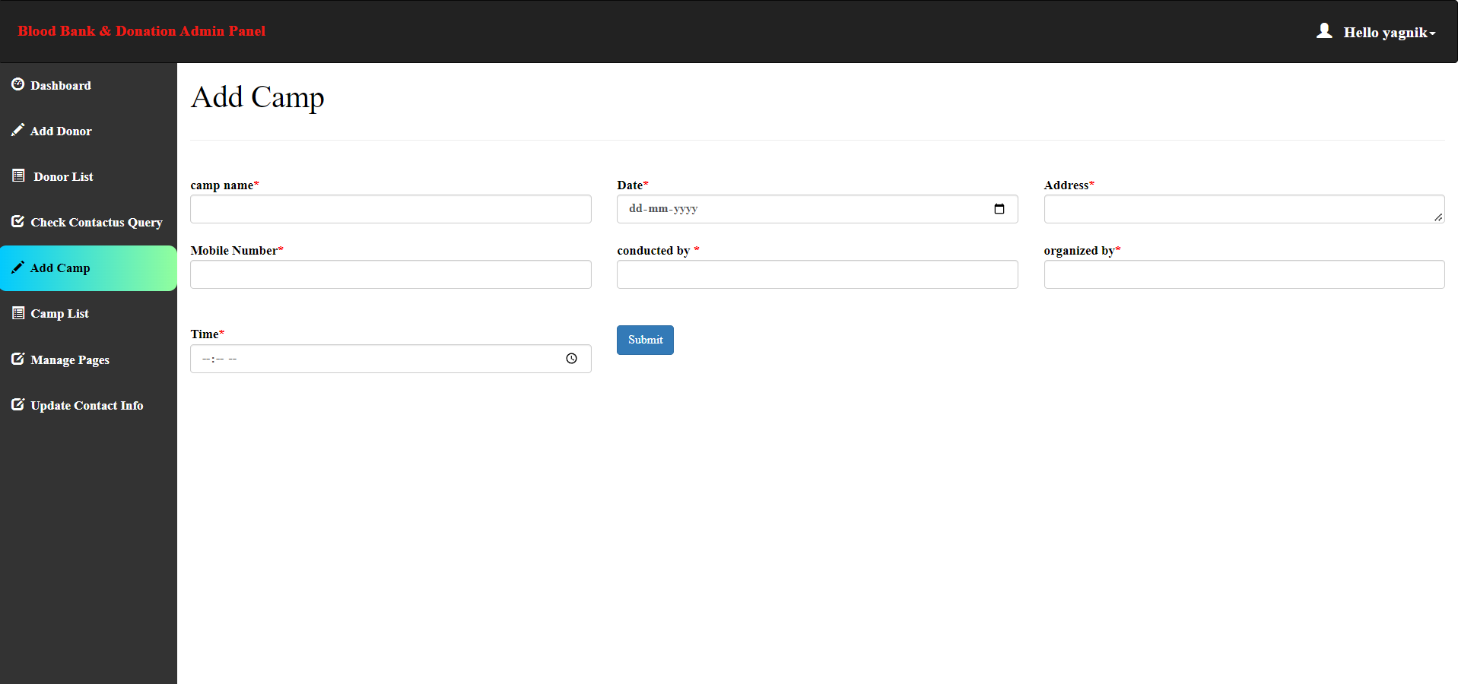
Design

- Camp List Page

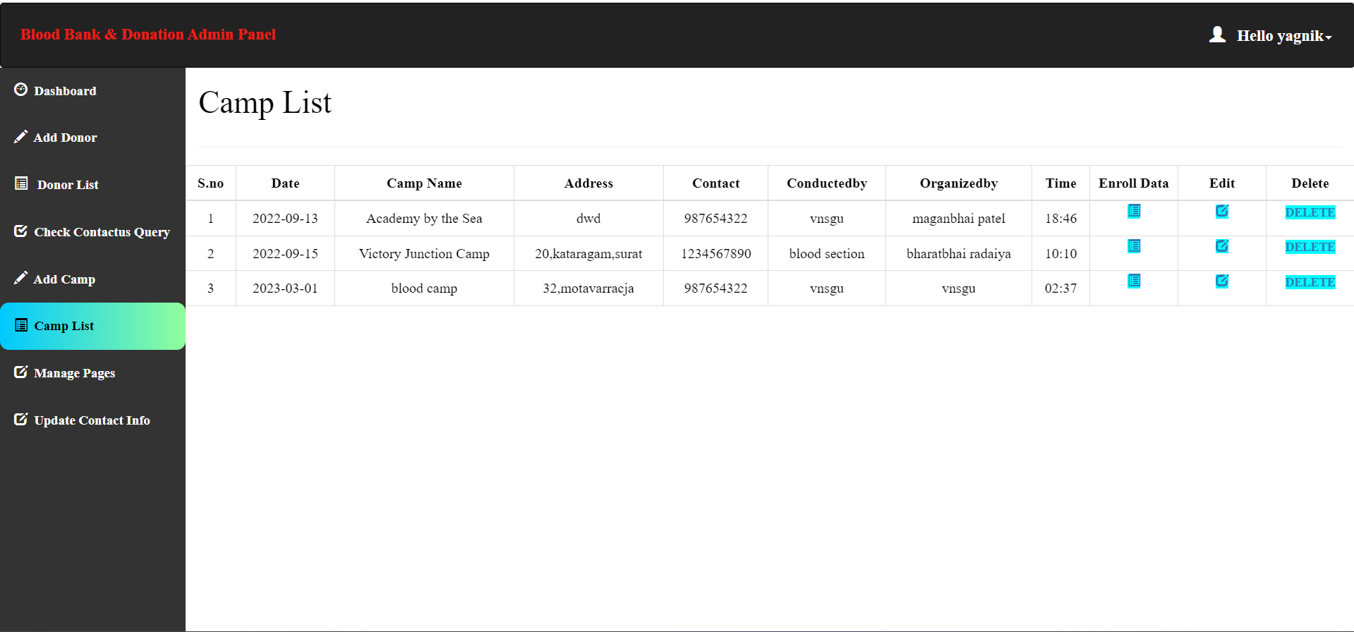

- Camp Enroll

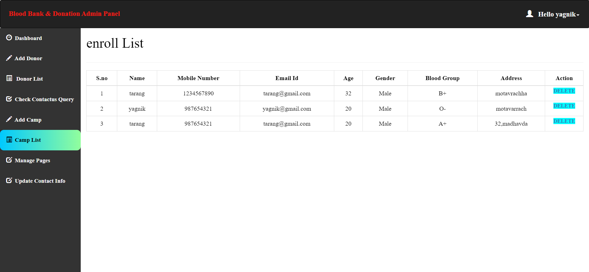
- Pages Data Manage

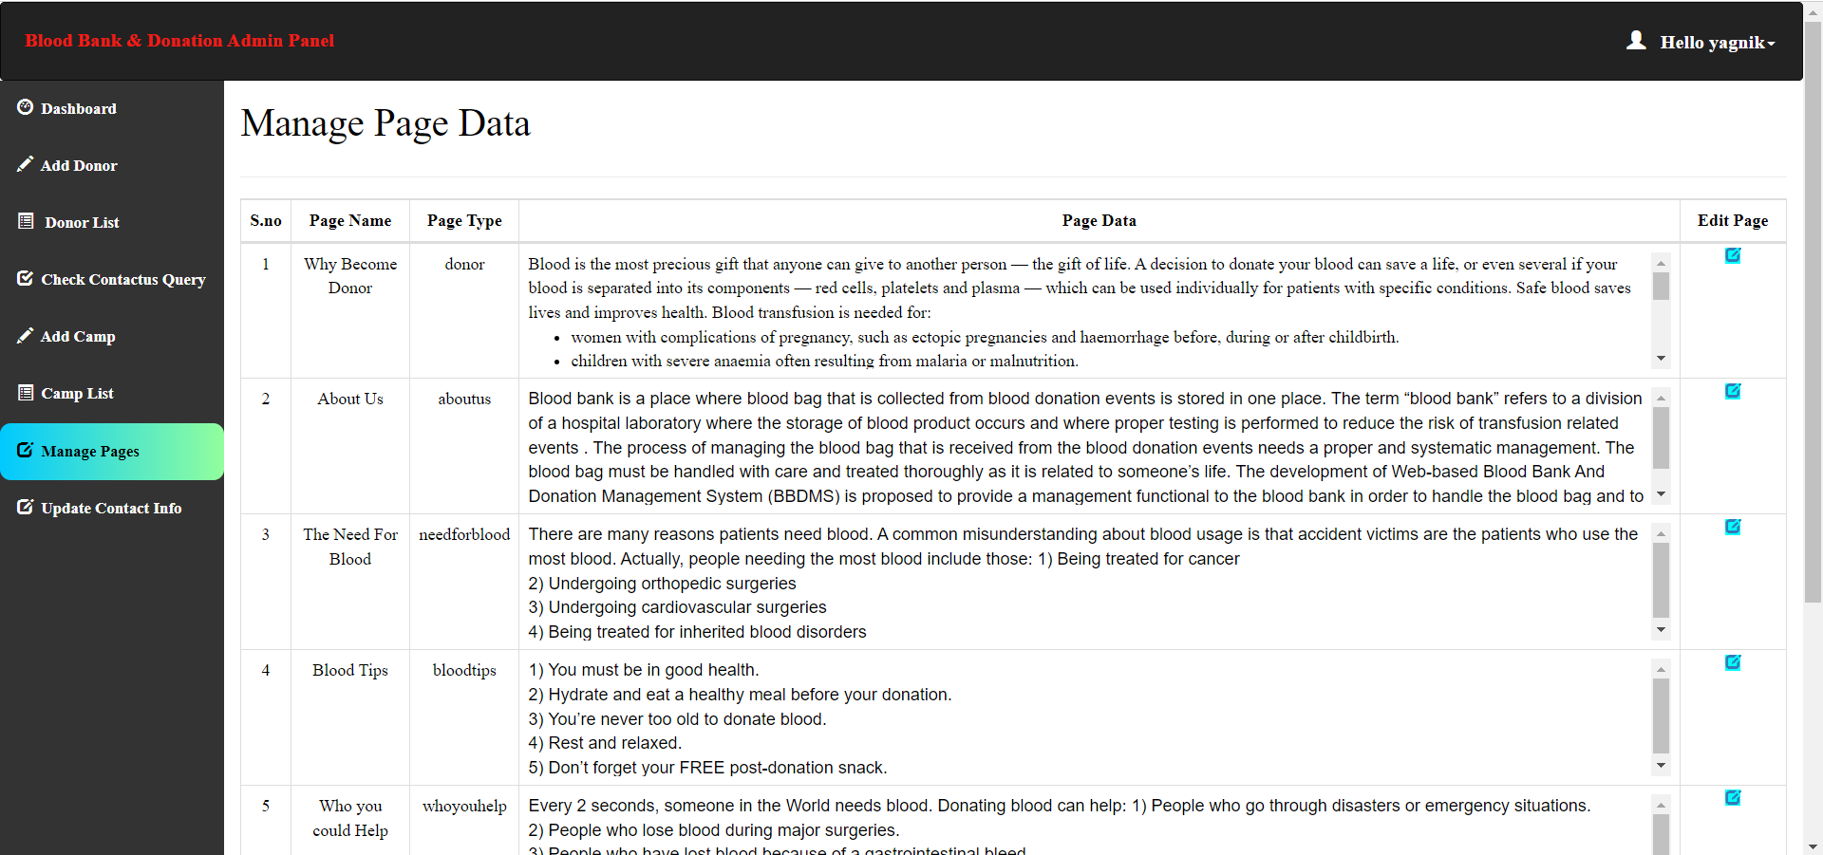
Design

- Update Admin Contact Info Page

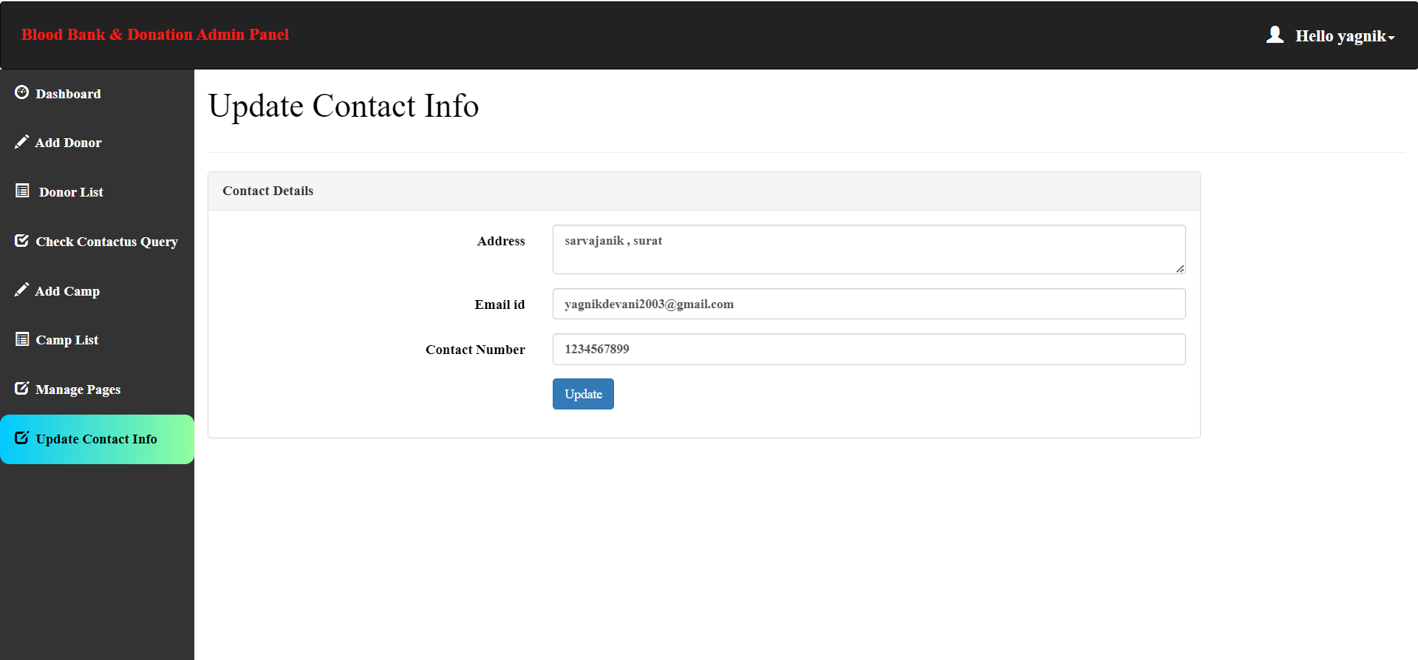

User Side :

- Home Page
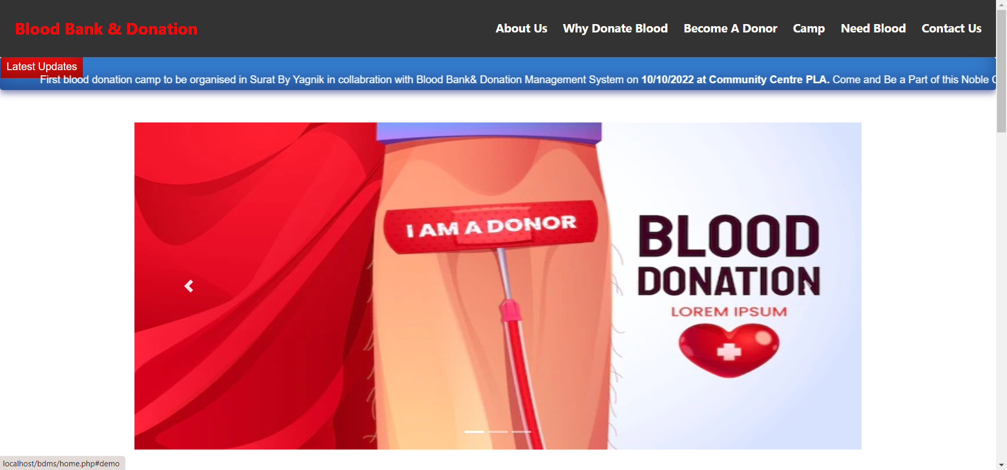
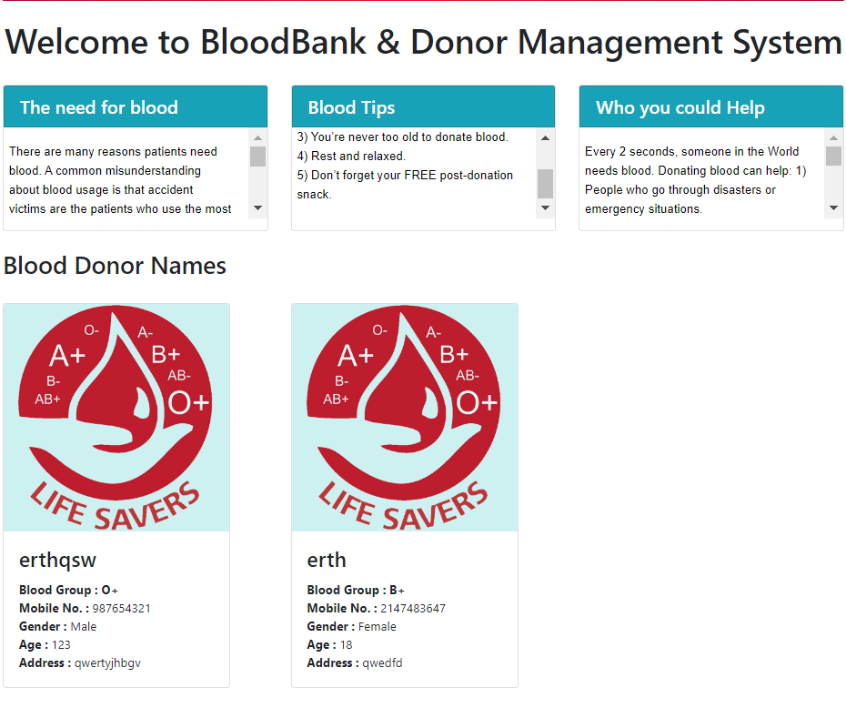
Design
Design
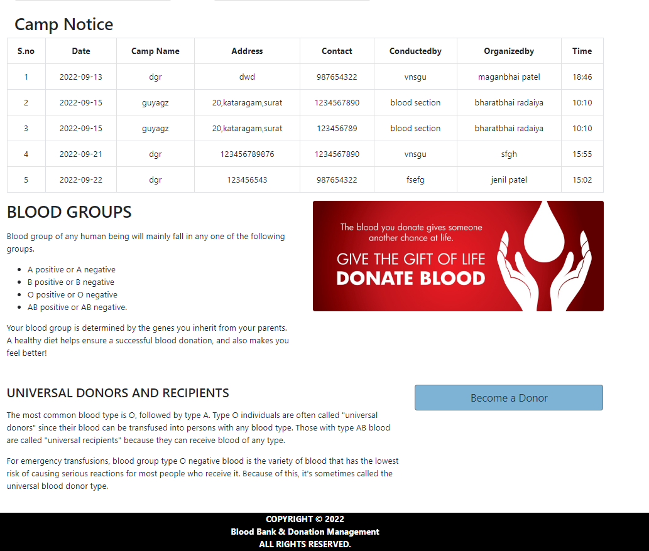
Design

- About Us Page
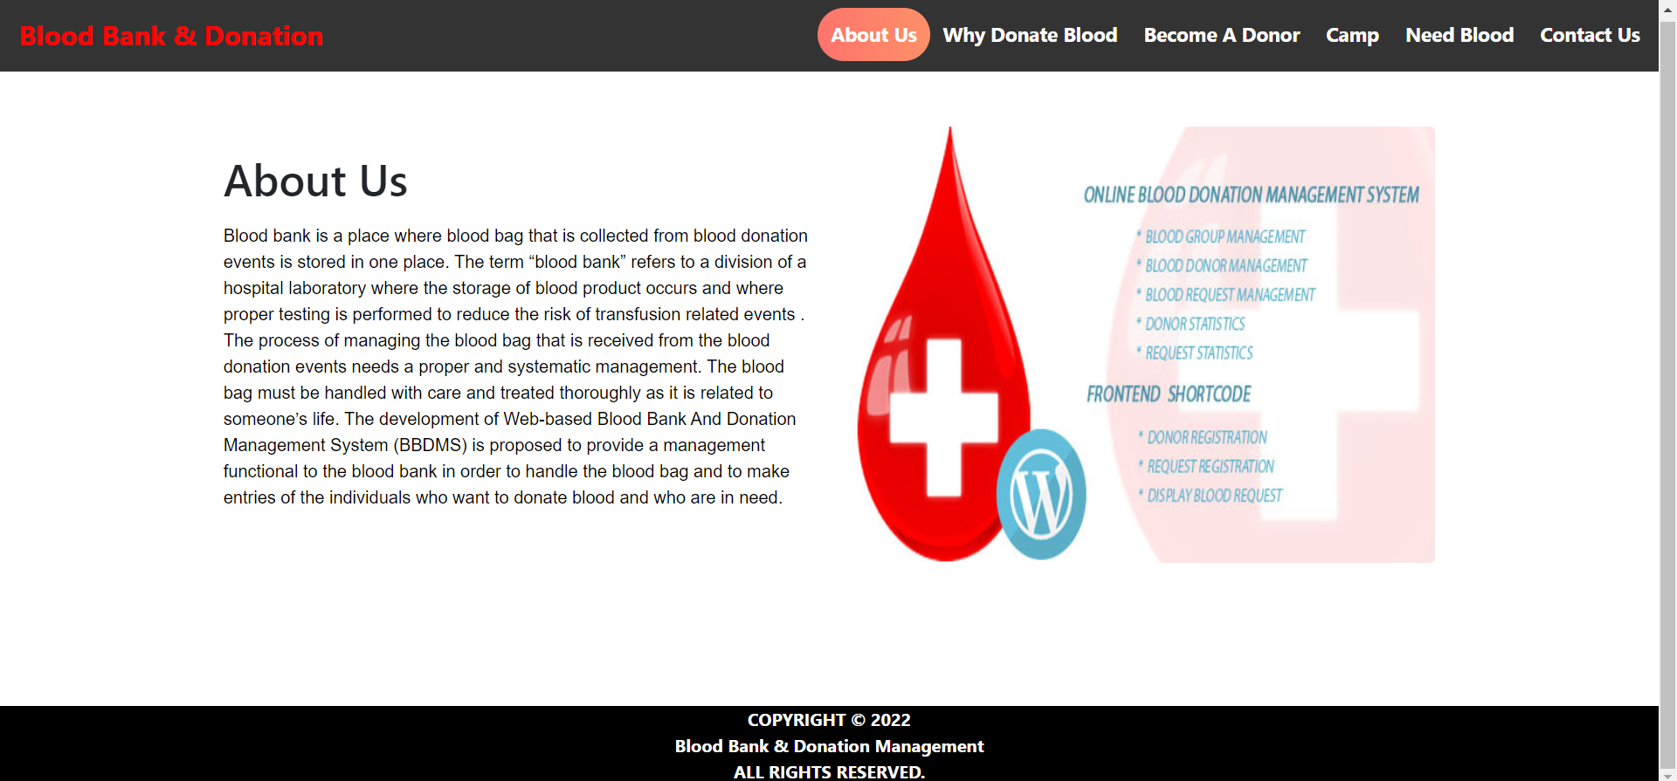
Design

- Why Donate Blood Page

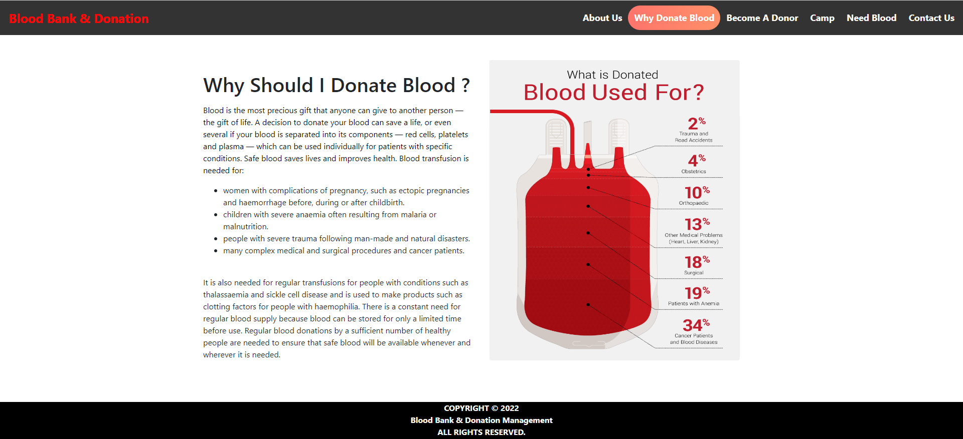

- Donate Blood Page

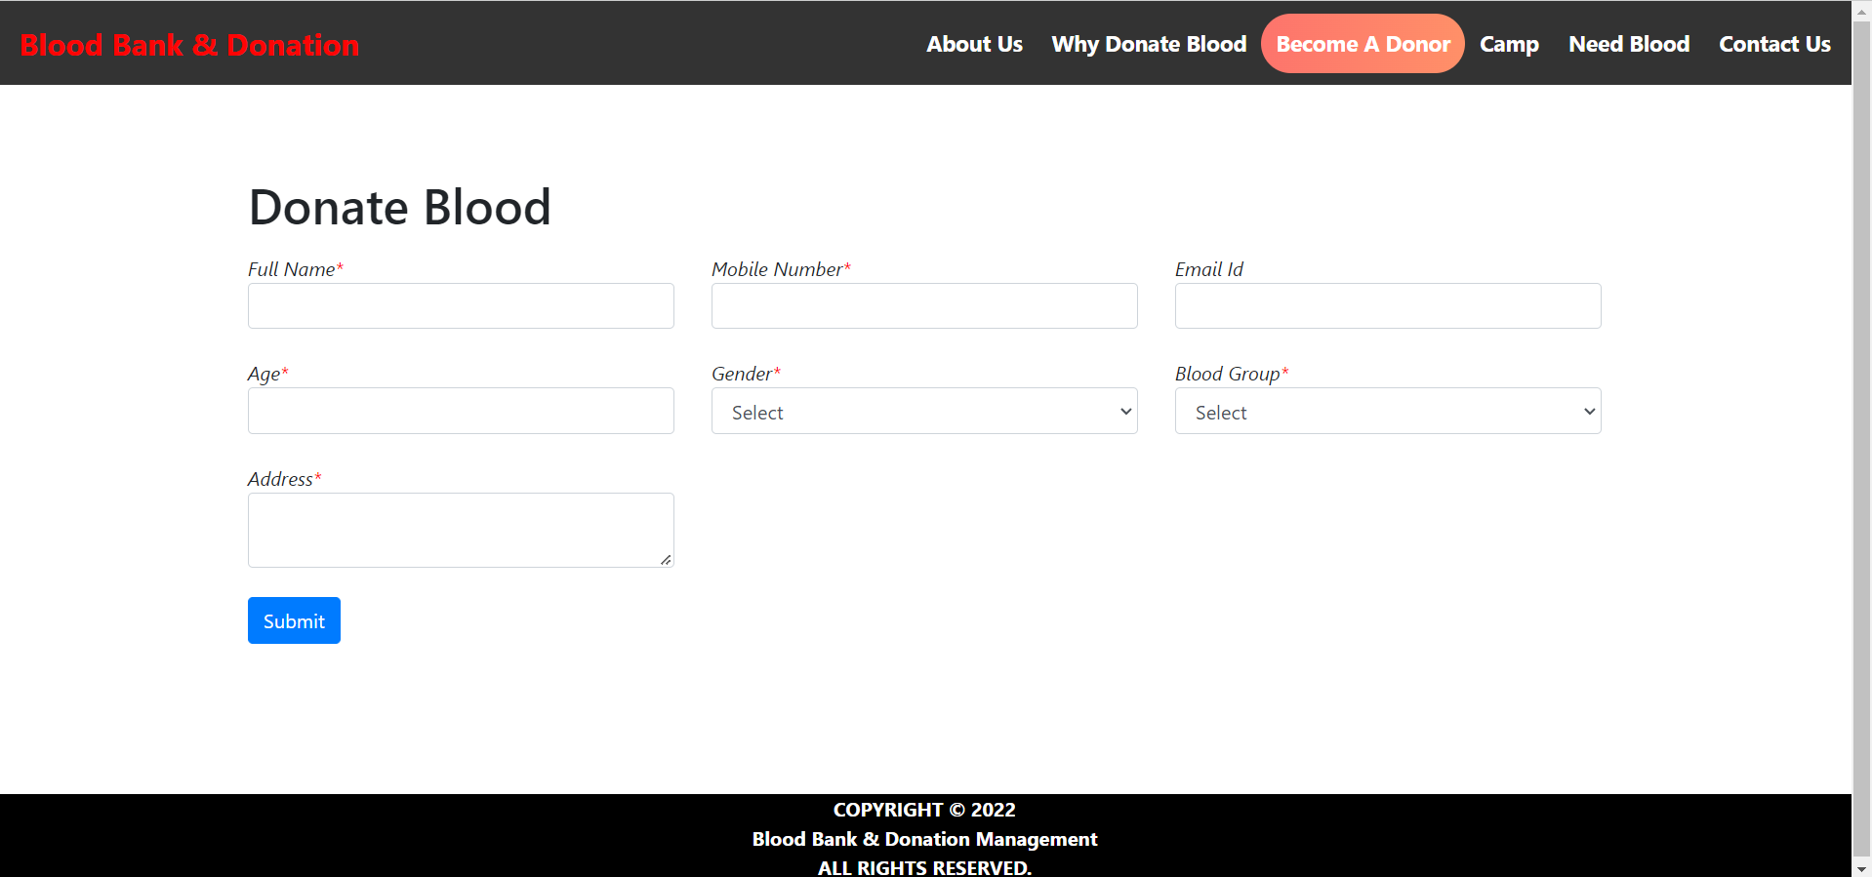
Design

- Camp Page

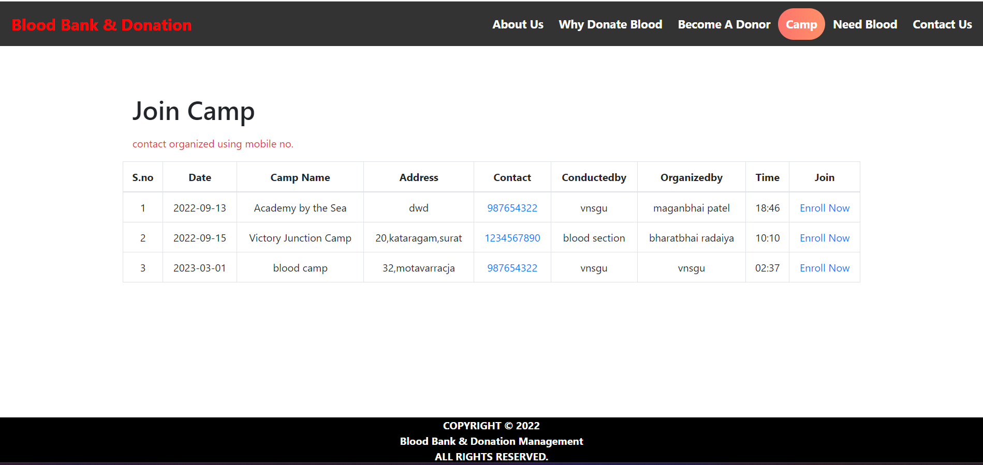

- Camp Enroll
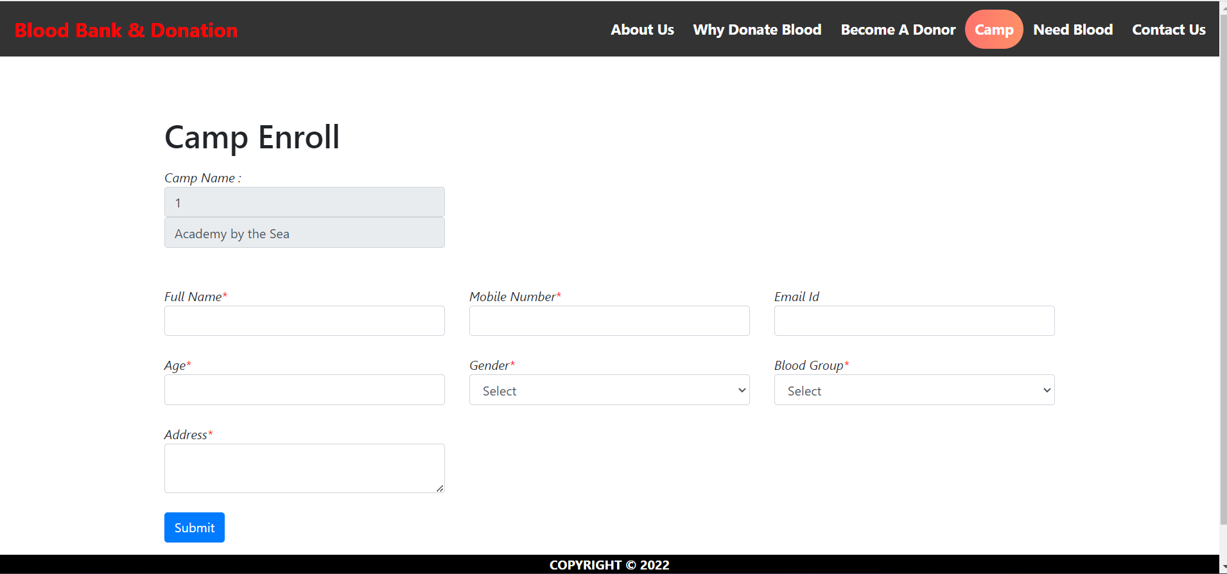
- Search Blood Page

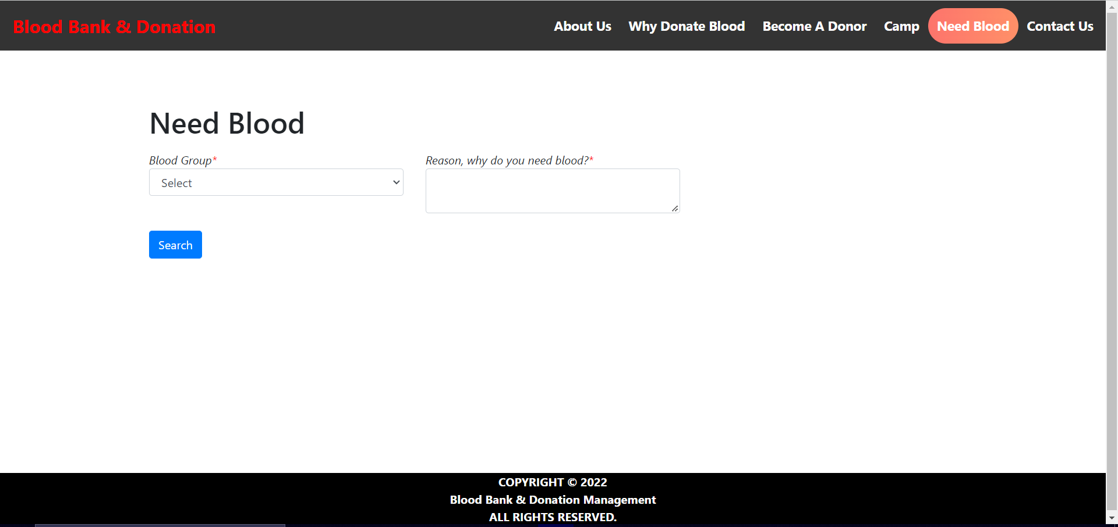
Design

- Admin Contact Query Page

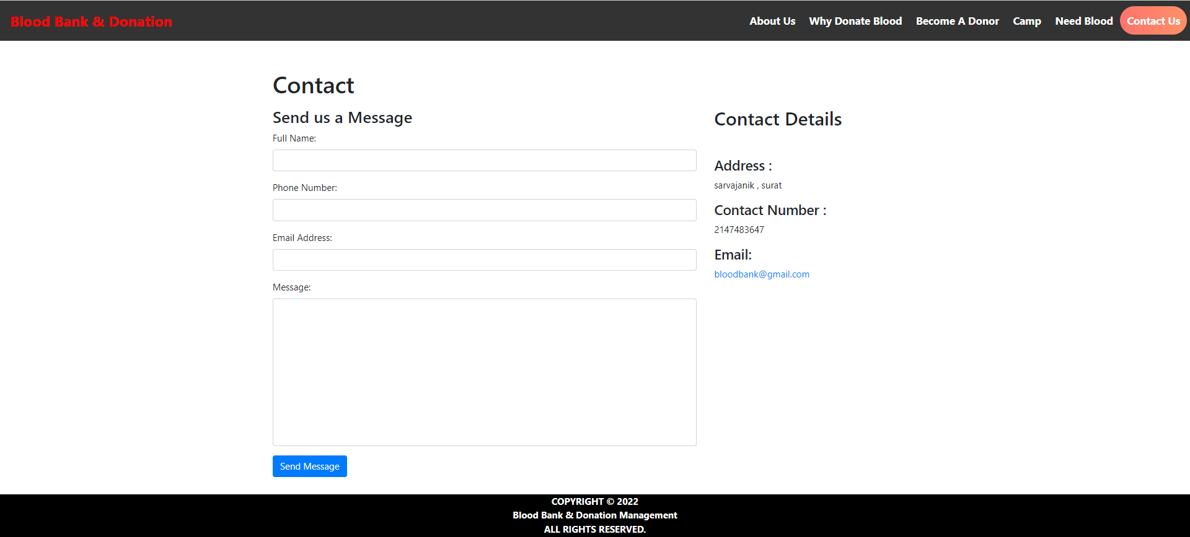

5. Code
Code

User Side :

Donate Blood
<html>

<head>
<meta charset="utf-8">
<meta name="viewport" content="width=device-width, initial-scale=1, shrink-to-fit=no">
<meta name="description" content="">
<meta name="author" content="">
<link rel="stylesheet" href="https://maxcdn.bootstrapcdn.com/bootstrap/4.5.2/css/bootstrap.min.css">
<script src="https://ajax.googleapis.com/ajax/libs/jquery/3.5.1/jquery.min.js"></script>
<script src="https://cdnjs.cloudflare.com/ajax/libs/popper.js/1.16.0/umd/popper.min.js"></script>
<script src="https://maxcdn.bootstrapcdn.com/bootstrap/4.5.2/js/bootstrap.min.js"></script>
</head>

<body>
<?php
$active ='donate';
include('head.php') ?>

<div id="page-container" style="margin-top:50px; position: relative;min-height: 84vh;">
<div class="container">
<div id="content-wrap" style="padding-bottom:50px;">
<div class="row">
<div class="col-lg-6">
<h1 class="mt-4 mb-3">Donate Blood </h1>
</div>
</div>
<form name="donor" action="savedata.php" method="post">
<div class="row">
<div class="col-lg-4 mb-4">
Code
<div class="font-italic">Full Name<span style="color:red">*</span></div>
<div><input type="text" name="fullname" class="form-control" required></div>
</div>
<div class="col-lg-4 mb-4">
<div class="font-italic">Mobile Number<span style="color:red">*</span></div>
<div><input type="tel" id="phone" name="mobileno" pattern="[0-9]{10}" class="form-control" required></div>
</div>
<div class="col-lg-4 mb-4">
<div class="font-italic">Email Id</div>
<div><input type="email" name="emailid" class="form-control"></div>
</div>
</div>
<div class="row">
<div class="col-lg-4 mb-4">
<div class="font-italic">Age<span style="color:red">*</span></div>
<div><input type="number" name="age" class="form-control" min="19" required></div>
</div>
<div class="col-lg-4 mb-4">
<div class="font-italic">Gender<span style="color:red">*</span></div>
<div><select name="gender" class="form-control" required>
<option value="">Select</option>
<option value="Male">Male</option>
<option value="Female">Female</option>
</select>
</div>
</div>
<div class="col-lg-4 mb-4">
<div class="font-italic">Blood Group<span style="color:red">*</span></div>
<div><select name="blood" class="form-control" required>
<option value=""selected disabled>Select</option>
<?php
Code
include 'conn.php';
$sql= "select * from blood";
$result=mysqli_query($conn,$sql) or die("query unsuccessful.");
while($row=mysqli_fetch_assoc($result)){
?>
<option value=" <?php echo $row['blood_id'] ?>"> <?php echo $row['blood_group'] ?> </option>
<?php } ?>
</select>
</div>
</div>
</div>
<div class="row">
<div class="col-lg-4 mb-4">
<div class="font-italic">Address<span style="color:red">*</span></div>
<div><textarea class="form-control" name="address" required></textarea></div></div>
</div>
<div class="row">
<div class="col-lg-4 mb-4">
<div><input type="submit" name="submit" class="btn btn-primary" value="Submit" style="cursor:pointer"></div>
</div>
</div>
</div>
</div>
<?php include('footer.php') ?>
</div>
</body>
</html>

Need Blood
<html>
Code
<head>
<meta charset="utf-8">
<meta name="viewport" content="width=device-width, initial-scale=1, shrink-to-fit=no">
<meta name="description" content="">
<meta name="author" content="">
<link rel="stylesheet" href="https://maxcdn.bootstrapcdn.com/bootstrap/4.5.2/css/bootstrap.min.css">
<script src="https://ajax.googleapis.com/ajax/libs/jquery/3.5.1/jquery.min.js"></script>
<script src="https://cdnjs.cloudflare.com/ajax/libs/popper.js/1.16.0/umd/popper.min.js"></script>
<script src="https://maxcdn.bootstrapcdn.com/bootstrap/4.5.2/js/bootstrap.min.js"></script>
</head>

<body>
<?php
$active ='need';
include('head.php') ?>

<div id="page-container" style="margin-top:50px; position: relative;min-height: 84vh;">
<div class="container">
<div id="content-wrap" style="padding-bottom:50px;">

<div class="row">
<div class="col-lg-6">
<h1 class="mt-4 mb-3">Need Blood</h1>

</div>
</div>
<form name="needblood" action="" method="post">
<div class="row">
<div class="col-lg-4 mb-4">
<div class="font-italic">Blood Group<span style="color:red">*</span></div>
<div><select name="blood" class="form-control" required>
Code
<option value=""selected disabled>Select</option>
<?php
include 'conn.php';
$sql= "select * from blood";
$result=mysqli_query($conn,$sql) or die("query unsuccessful.");
while($row=mysqli_fetch_assoc($result)){
?>
<option value=" <?php echo $row['blood_id'] ?>"> <?php echo $row['blood_group'] ?> </option>
<?php } ?>
</select>
</div>
</div>

<div class="col-lg-4 mb-4">
<div class="font-italic">Reason, why do you need blood?<span style="color:red">*</span></div>
<div><textarea class="form-control" name="address" required></textarea></div></div>
</div>
<div class="row">
<div class="col-lg-4 mb-4">
<div><input type="submit" name="search" class="btn btn-primary" value="Search" style="cursor:pointer"></div>
</div>

</div><div class="row">
<?php if(isset($_POST['search'])){

$bg=$_POST['blood'];
$sql= "select * from donor_details join blood where donor_details.donor_blood=blood.blood_id AND donor_blood='{$bg}' order by rand() limit 5";
$result=mysqli_query($conn,$sql) or die("query unsuccessful.");
if(mysqli_num_rows($result)>0) {
while($row = mysqli_fetch_assoc($result)) {
Code
?>

<div class="col-lg-4 col-sm-6 portfolio-item" ><br>
<div class="card" style="width:300px">
<img class="card-img-top" src="image\blood_drop_logo.jpg" alt="Card image" style="width:100%;height:300px">
<div class="card-body">
<h3 class="card-title"><?php echo $row['donor_name']; ?></h3>
<p class="card-text">
<b>Blood Group : </b> <b><?php echo $row['blood_group']; ?></b><br>
<b>Mobile No. : </b> <?php echo $row['donor_number']; ?><br>
<b>Gender : </b><?php echo $row['donor_gender']; ?><br>
<b>Age : </b> <?php echo $row['donor_age']; ?><br>
<b>Address : </b> <?php echo $row['donor_address']; ?><br>
</p>

</div>
</div>
</div>

<?php
}
}
else
{

echo '<div class="alert alert-danger">No Donor Found For your search Blood group </div>';

}
} ?>
</div>
</div>
Code
</div>
<?php include 'footer.php' ?>
</div>
</body>

</html>

6. Testing
Testing

- Registration Page:

NO. | Input | Description | Expected Output | Actual Output | Result
1 | Empty UserName | Blank | Error | Error | Registration Fail
2 | Empty  Email | Blank/Wrong/Not Valid Formate | Error | Error | Registration Fail
3 | Empty  Mobile no | Blank/  Require 10 Digit | Error | Error | Registration Fail
4 | Empty  /18 above age | Blank/Wrong | Error | Error | Registration Fail

1 )
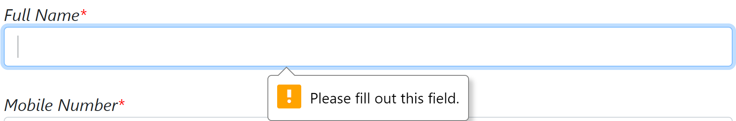
2 )
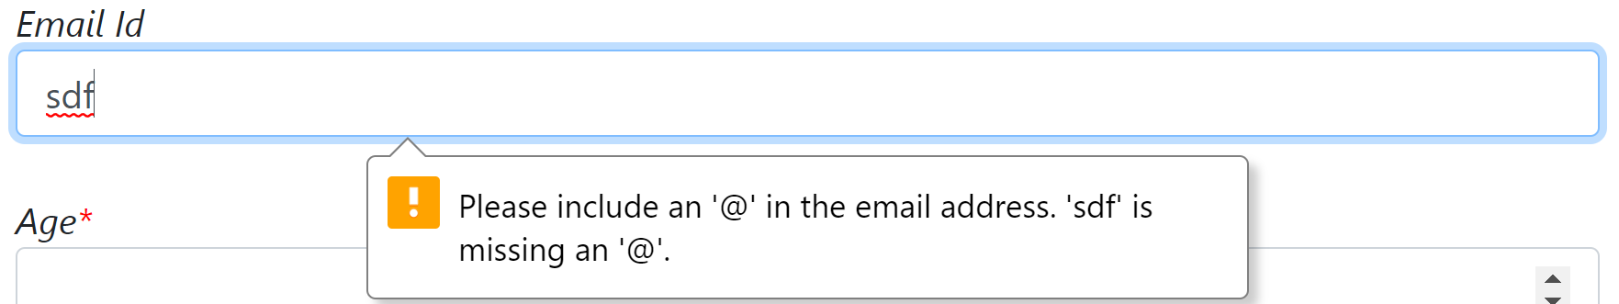
3 )
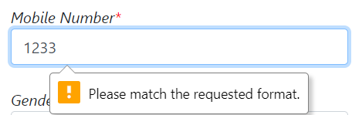
Testing
4 )
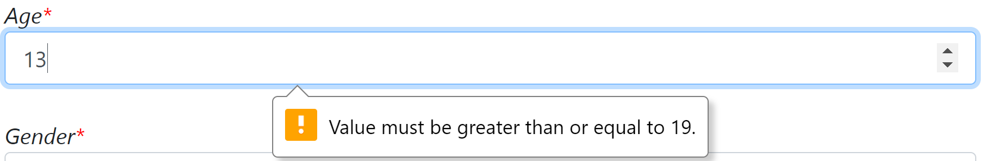

Testing

- Login Page:

NO. | Input | Description | Expected Output | Actual Output | Result
1 | Empty UserName | Blank | Error | Error | Login Fail
2 | Empty  /Wrong password | Blank/Wrong | Error | Error | Login Fail

1)
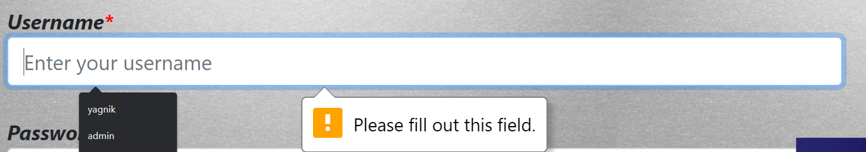

2)
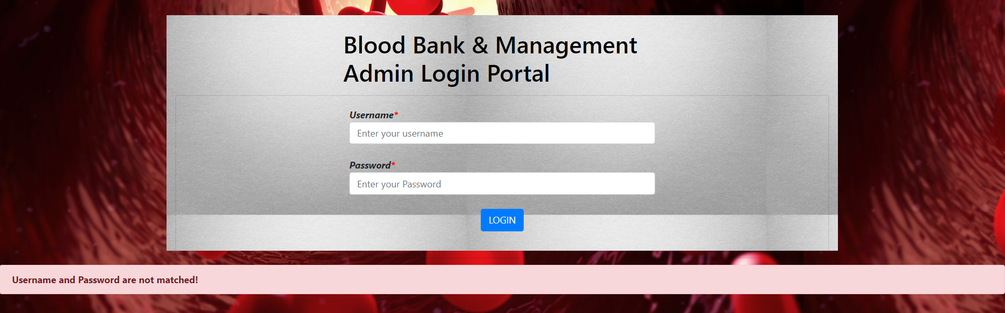

Testing
- Camp Page:

NO. | Input | Description | Expected Output | Actual Output | Result
1 | Empty CampName | Blank | Error | Error | Camp Registration Fail
2 | Empty  Date | Blank | Error | Error | Camp Registration Fail
3 | Empty  Mobile no | Blank  Require 10 Digit | Error | Error | Camp Registration Fail
4 | Empty  /Address | Blank | Error | Error | Camp Registration Fail
5 | Empty  /Time | Blank | Error | Error | Camp Registration Fail
6 | Empty  /conducted  /organized | Blank | Error | Error | Camp Registration Fail
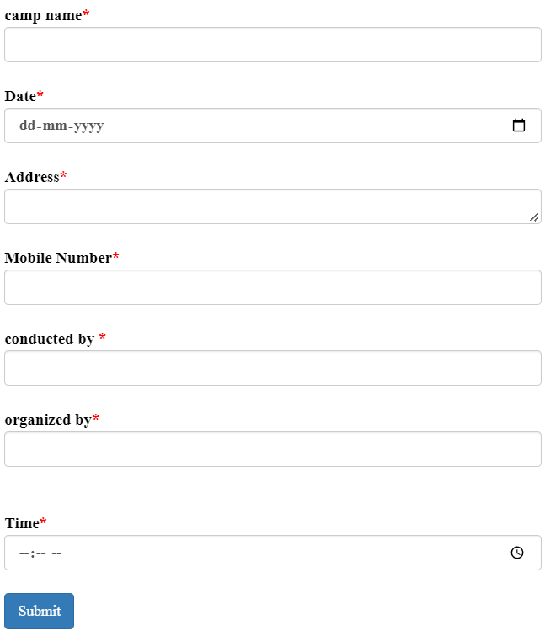
Testing

New Tools

7.0 NEW TOOLS/ TECHNOLOGIES LEARNED/ USED:

- HTML

- CSS

- JavaScript

- Bootstrap

- PHP

- My SQL Database (PHP My Admin)

Limitation

8.0 SYSTEM LIMITATION/CONSTRAINTS:

- User can not get email

- Admin not add directly admin add by other admin

- Camp contact using website

Future Scope

9.Future Enhancement & Opportunities

- More efficient design and user experience.
- Apply More efficient constraints .
- Add module to admin can change password using Mobile
No./Email OTP.
- Add feature of login/signup using google / facebook.

References

10. BIBLIOGRAPHY & REFERENCES:

Books
- PHP: Learn PHP in 24 Hours or Less - A Beginner's Guide To Learning PHP Programming Now

Website

- www.stackoverflow.com
- www.javatpoint.com
- www.tutorialspoint.com

